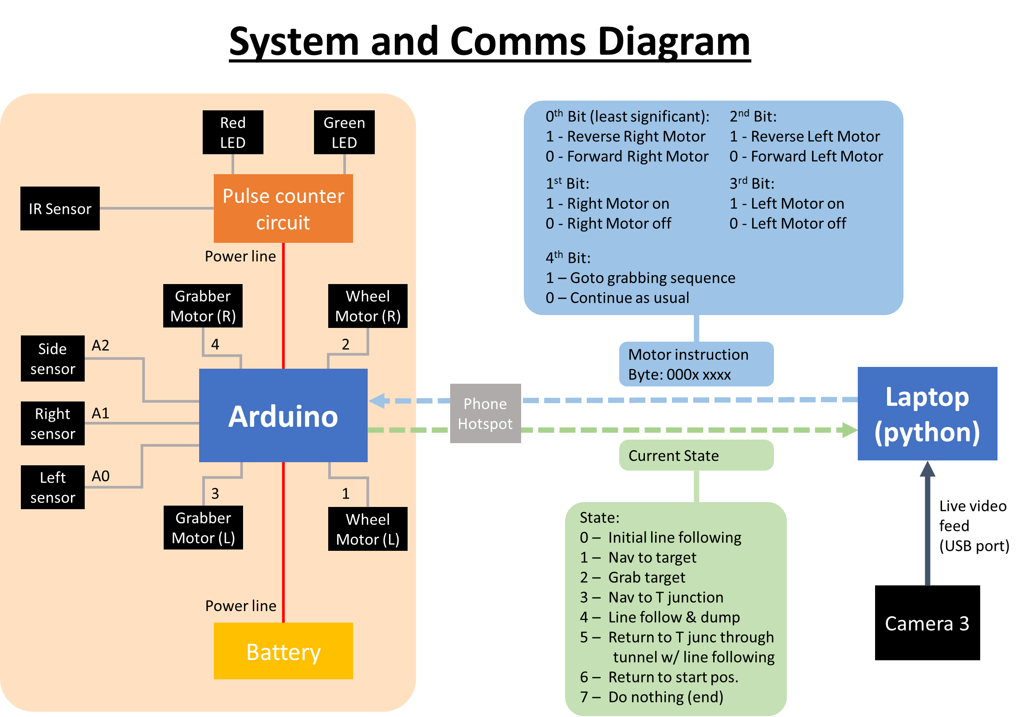

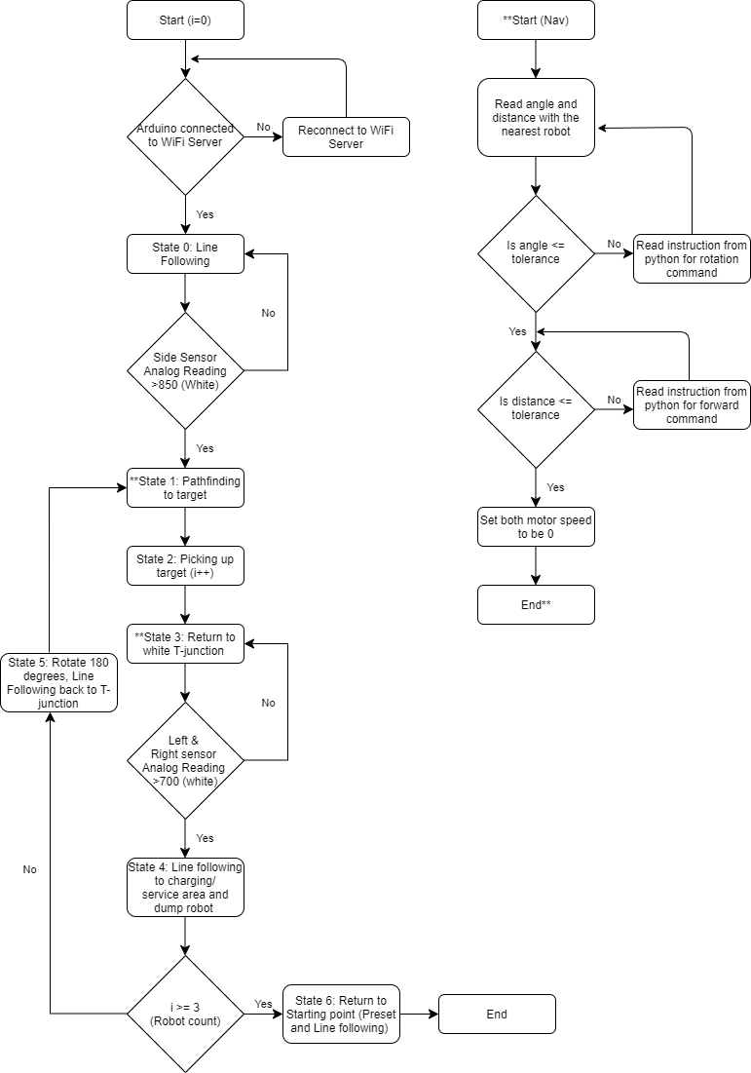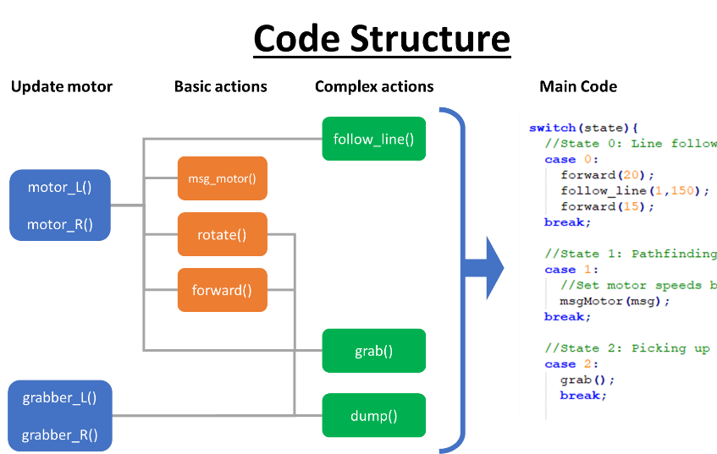

**Code for Arduino**

#include <SPI.h>

#include <WiFiNINA.h>

#include <Wire.h>

#include <Adafruit_MotorShield.h>

//Motor init

Adafruit_MotorShield AFMS = Adafruit_MotorShield();

Adafruit_DCMotor *motorL = AFMS.getMotor(1); //Left wheel motor

Adafruit_DCMotor *motorR = AFMS.getMotor(2); //Right wheel motor

Adafruit_DCMotor *motorGrL = AFMS.getMotor(3); //Left grabber motor

Adafruit_DCMotor *motorGrR = AFMS.getMotor(4); //Right wheel motor

#define LM1 3

#define RM1 4

//Variables

//----------------------------

//State of the robot i.e. current objective

int state = 0; // 0 = line following, 1 = pathfinding ,2 = ....

int targetsCollected = 0; //Number of targets currently collected

//Line following

bool sensor_l; // Line following sensor readings

bool sensor_r; // 1 = white, 0 = black

bool sensor_s;

int sensor_s_timer=0; //Ignore side sensor for first x cycles

bool L_faster_LF; // 1 = faster, 0 = slower

bool R_faster_LF;

double tol=700; //Tolerance for left and right sensor

double tol_s=850; //Tolerance for side sensor

//Wifi

char ssid[] = "OnePlus 7 Pro"; //SSID

char pass[] = "www.youtube.com/watch?v=dQw4w9WgXcQ"; //password

uint8_t msg=0; //Variable to store message

uint8_t buf; //Byte in buffer

size_t siz = 1; //Size of buffer

int status = WL_IDLE_STATUS; //Wifi status

bool alreadyConnected;

WiFiServer server(23); //Start server

//Motor variables

int speed_L_current=0; //Current speed of the motor (L)

int speed_R_current=0; //Current speed of the motor (R)

int speed_L; //Intended speed of the motor (L)

int speed_R; //Intended speed of the motor (R)

uint8_t v=128; //Default speed

uint8_t v_LF=200; //Line following speed

//Motor parameters

double ang2t = 24; //time (ms) taken to rotate one degree for AGV

double dis2t = 100;

uint8_t v_m = 128; //Speed for grabber motor

//Gripper calibration

double ang2t_ml = 10.5; //time (ms) taken to rotate one degree for gripper motor (L)

double ang2t_mr = 35; //time (ms) taken to rotate one degree for gripper motor (R)

//Functions

//----------------------------

//Update motor speed

void motor_L(int speed){

if (speed != speed_L_current){

motorL->run( (speed>=0) ? FORWARD : BACKWARD );

motorL->setSpeed(abs(speed));

speed_L_current = speed;

}

}

void motor_R(int speed){

if (speed != speed_R_current){

motorR->run( (speed>=0) ? FORWARD : BACKWARD );

motorR->setSpeed(abs(speed));

speed_R_current = speed;

}

}

//Rotation and move forward

void rotate(double angle){

//Angle +ve clockwise

motor_L((angle>=0) ? v : -v);

motor_R((angle>=0) ? -v : v);

delay(abs(angle)*ang2t);

motor_L(0);

motor_R(0);

}

void forward(double dist){

//dist +ve forward

motor_L((dist>=0) ? v : -v);

motor_R((dist>=0) ? v : -v);

delay(abs(dist)*dis2t);

motor_L(0);

motor_R(0);

}

//Line Follower

void follow_line(bool keepRight, int sensor_s_timer){

// keepRight: 1 -> AGV follows right side of line , 0-> AGV follows left side of line

// sensor_s_timer = min number of cycles for line following

while (1){

//Sensor readings

sensor_l = (analogRead(A0)>tol) ? 1 : 0;

sensor_r = (analogRead(A1)>tol) ? 1 : 0;

sensor_s = (analogRead(A2)>tol_s) ? 1 : 0;

//Determine motor speeds via boolean logic

L_faster_LF = keepRight ? (sensor_l || sensor_r) : (!sensor_l);

R_faster_LF = keepRight ? (!sensor_r) : (sensor_l || sensor_r);

//Exit condition

if (sensor_s && sensor_s_timer<=0){

motor_L(0);

motor_R(0);

return;

}

//Update speeds

motor_L(L_faster_LF ? v_LF : 0);

motor_R(R_faster_LF ? v_LF : 0);

//Delay and move to next loop

sensor_s_timer --;

delay(50);

}

}

//Update motor speeds from bytes sent from python

void msgMotor(uint8_t msg){

//Left motor: 0th bit = move/not move, 1st bit = reverse

motor_L( (bitRead(msg,3) ? v : 0) * (bitRead(msg,2) ? -1 : 1) );

//Right motor: 2nd bit = move/not move, 3rd bit = reverse

motor_R( (bitRead(msg,1) ? v : 0) * (bitRead(msg,0) ? -1 : 1) );

}

//Move grabber arm

void grabber_R(int angle){

motorGrR->run( (angle>=0) ? FORWARD : BACKWARD );

motorGrR->setSpeed(v_m);

delay(abs(angle)*ang2t_mr);

motorGrR->setSpeed(0);

}

void grabber_L(int angle){

motorGrL->run( (angle>=0) ? BACKWARD : FORWARD );

motorGrL->setSpeed(v_m);

delay(abs(angle)*ang2t_ml);

motorGrL->setSpeed(0);

}

//Grab target sequence

void grab(){

forward(-15);

grabber_R(110);

grabber_L(150);

forward(22);

grabber_R(-95);

grabber_R(7);

grabber_L(-150);

delay(1000);

grabber_R(-35);

}

//Release target sequence

void dump(){

grabber_R(90);

forward(-20);

grabber_R(-110);

}

//Actual code in robot

//----------------------------

void setup(){

//Turn on motorshield and serial

AFMS.begin();

Serial.begin(9600);

server.begin();

//Sensor inputs

pinMode(A0, INPUT); //left sensor as input

pinMode(A1, INPUT); //right sensor as input

pinMode(A2, INPUT); //Side sensor as input

}

void loop(){

//Wifi stuff

if (status != WiFi.status()) {

status = WiFi.status();

}

//Keep tring to connect if not connected

if (status != WL_CONNECTED){

//Stop robot if disconnected

motor_L(0);

motor_R(0);

while (status != WL_CONNECTED) {

status = WiFi.begin(ssid, pass);

// wait 5 seconds for each attempt

delay(5000);

}

alreadyConnected = false;

}

//Read connection if there is client

WiFiClient client = server.available();

if (client) {

if (!alreadyConnected) {

// clead out the input buffer:

client.flush();

alreadyConnected = true;

}

if (client.available() > 0) {

// read the bytes incoming from the client:

client.read(&buf , siz);

msg = buf+1-1;

}

}

//Switch statement based on current state of the robot

switch(state){

//State 0: First Line following

case 0:

forward(20);

follow_line(1,150);

forward(15);

state = 1;

break;

//State 1: Pathfinding to target

case 1:

//Update motor speeds based on inputs from python

msgMotor(msg);

//Exit condition (4th bit is signal from python that it is in front of the robot)

if (bitRead(msg,4)){

motor_L(0);

motor_R(0);

state = 2;

}

break;

//State 2: Picking up target

case 2:

grab();

state=3;

targetsCollected++;

break;

//State 3: return to T junction

case 3:

//Sensor readings

sensor_l = (analogRead(A0)>tol) ? 1 : 0;

sensor_r = (analogRead(A1)>tol) ? 1 : 0;

//Update motor speeds based on inputs from python

msgMotor(msg);

//Exit condition (if both sensors read white it thinks it reached the T junction)

if (sensor_r && sensor_l){

state = 4;

motor_L(0);

motor_R(0);

}

break;

//State 4: Line follow to charging/service area

case 4:

forward(10);

rotate(10);

follow_line(1,0);

//Dump after line follow

dump();

forward(10);

//If all target collected, go to state 6, else go to state 5

if (targetsCollected >= 3){

state = 6;

} else {

state = 5;

}

break;

//State 5: Turn around and line follow back to T junction

case 5:

rotate(-200);

follow_line(0,150);

forward(15);

state = 1;

msg=0;

break;

//State 6: End - Return to starting white box

case 6:

rotate(-150);

forward(45);

follow_line(1,0);

forward(30);

state = 7;

break;

//State 7: end

case 7:

motor_L(0);

motor_R(0);

//do nothing

break;

}

//Send current state to python

server.write(state);

}

**Code for Python**

import numpy as np

import cv2 as cv

import telnetlib

#------------Initialisation-----------#

#Import video

cap = cv.VideoCapture(0)

width = int(cap.get(3))

height =int(cap.get(4))

print("Vid dimentions: ",width,"x",height)

#Connect to arduino via telnetlib

ip = "192.168.43.224"

port = 23

connection = False

#Start trigger

StartTrigger = input("Enter any key")

#------------Parameters-----------#

#Cropping parameters (pixels)

crop = [19,320] #[Left,Right]

tunnel = [163,288,288,384] #[Left,top,right,bottom]

#Display Box params, w= width, h=height, dof = offset from center

agv = {'w':65,'h':100,'dof':10}

grp = {'w':90,'h':40,'dof':70}

#Thresholding for rectangle detection for AGV

#ca_th : min contour area compared to bounding rectangle threshold

markerH = {'min_area':450,'max_area':800,'min_ratio':2,'max_ratio':4.5,'ca_th':0.5}

markerV = {'min_area':200,'max_area':450,'min_ratio':2,'max_ratio':4.5,'ca_th':0.5}

#Navigation parameters

agv_COR = 1.95 #Placement of the center of rotation of the AGV

min_dist_target = 91 #Stopping distance (pixels) when navigating to target

tol_dist_point = 3 #Stopping distance (pixels) when navigating to a point

ang2t = 7 #Time taken (frames) for rotation of one radian

tol_angle = 0.1 #Tolerance for angle rotation (radians)

T_coords = [250,225] #Coordinates for T junction (pixels)

#Init variables

agv_coords = [0,440] #Default position for AGV

rot_angle = 0 #Default rotation angle

motor = [0,0,0,0] #Bits:[Left motor On, Left motor reverse, Right motor on, Right motor reverse]

#Keep track of current action and target

action = {'mode':'none','timer':0,'dir':1} #Mode:none,fwd,rot,stop, dir: 0:fwd, 1:rev

nav = {'type':'t','target' : [70,250]} #Target (t), Waypoint(w), Endpoint(p)

targets = [] #Target list

state = -1 #Default state

#------------Functions-----------#

#Returns angle between two vectors

def angle(v1,v2):

return np.arctan2(np.cross(v2,v1),np.dot(v2,v1))

#Rounds number to nearest multiple

def nearestmultiple(x,base):

return base*round(x/base)

#Returns black white image which is a linear sum combination of RGB channels (stored in a)

def linrgb(img,a):

if(len(a))==3:

a.append(0)

img = np.asarray(img,dtype='int16')

out = a[0]*img[:,:,0]+a[1]*img[:,:,1]+a[2]*img[:,:,2]+a[3]

out = np.clip(out,a_min=0,a_max=255)

return np.asarray(out, dtype='uint8' )

#Check is rectangle is correct for AGV tracking

def valid_rect(w,h,min_area,max_area,min_ratio,max_ratio,carea,ca_th):

w,h = int(w),int(h)

area = w*h

if area>0 and area >= min_area and area <= max_area and carea>area*ca_th:

ratio = max(w/h,h/w)

if ratio>=min_ratio and ratio<=max_ratio :

return True

return False

#Drawing visuals on laptop

def draw_visuals(output,agv_coords,rot_angle):

#Box for agv

rect_agv = (

(agv_coords[0]+agv['dof']*np.cos(rot_angle),agv_coords[1]+agv['dof']*np.sin(rot_angle)),

(agv['h'],agv['w']),rot_angle * 180/np.pi)

box_agv = np.int0(cv.boxPoints(rect_agv))

#Box for gripper area

rect_grp = (

(agv_coords[0]+grp['dof']*np.cos(rot_angle),agv_coords[1]+grp['dof']*np.sin(rot_angle)),

(grp['h'],grp['w']),rot_angle * 180/np.pi)

box_grp = np.int0(cv.boxPoints(rect_grp))

#Line

line_length = 200

centre_point = (int(agv_coords[0]),int(agv_coords[1]))

line_point = (int(agv_coords[0]+line_length*np.cos(rot_angle)),int(agv_coords[1]+line_length*np.sin(rot_angle)))

#Draw boxes

cv.circle(output,centre_point,5,(128,128,0),10)

cv.circle(output,tuple(T_coords),5,(128,128,128),10)

cv.drawContours(output,[box_agv],0,(255,255,0),3)

cv.drawContours(output,[box_grp],0,(255,255,0),3)

cv.line(output,centre_point,line_point,(0,0,255),1)

#Draw cropped area

cv.rectangle(output,(tunnel[1],tunnel[0]),(tunnel[3],tunnel[2]),(255,0,0),3)

cv.rectangle(output,(crop[0],0),(crop[1],width),(255,0,0),3)

#------------Main Loop-----------#

while(cap.isOpened()):

#Read frame

ret,frame = cap.read()

#Quit if no frame

if frame is None:

break

#Attempt to connect to arduino

if connection == False:

print("Trying to reconnect")

try:

connection = telnetlib.Telnet(ip,port,2)

except:

connection = False

print("No Connection")

#Display output

output = frame+0

#Crop frame

frame[:,crop[1]:width,:] = 0

frame[:,0:crop[0],:] = 0

frame[tunnel[0]:tunnel[2],tunnel[1]:tunnel[3],:] = 0

#Read input msg

prevstate = state + 0

if connection != False:

try:

msg = connection.read_eager()

if len(msg)>0:

state = msg[-1]

except:

connection = False

#-----Finding the targets-----#

#Isolate green channel and low pass filter

mask_th_tgt = linrgb(frame,[-2,4,-2])

mask_th_tgt = cv.medianBlur(mask_th_tgt,5)

#Thresholding and finding countours

thresh_lower = 150

cv.imshow('Mask_t',mask_th_tgt)

_,mask_th_tgt = cv.threshold(mask_th_tgt,thresh_lower,255,cv.THRESH_BINARY)

contours,_ = cv.findContours(mask_th_tgt,cv.RETR_TREE,cv.CHAIN_APPROX_NONE)

#Store targets in a list

tgt_count = 0

targets = []

for contour in contours:

(x,y,w,h) = cv.boundingRect(contour)

if cv.contourArea(contour)>20:

tgt_count += 1

cv.rectangle(output,(x,y),(x+w,y+h),(0,255,255),3)

targets.append([

int(x+w/2),

int(y+h/2),

nearestmultiple( np.linalg.norm([x+w/2-T_coords[0],y+h/2-T_coords[1]]) ,30)

])

#Sort by distance, and then by y coordinate

targets = sorted(targets, key=lambda x:x[1])

targets = sorted(targets, key=lambda x:x[2])

#-----Finding the AGV------#

#Isolate red and blue channel and low pass filter

mask_th_agv = linrgb(frame,[2,-4,2,0])

mask_th_agv = cv.medianBlur(mask_th_agv,5)

#Thresholding and finding countours

cv.imshow('Mask_agv',mask_th_agv)

_,mask_th_agv = cv.threshold(mask_th_agv,50,255,cv.THRESH_BINARY)

contours,_ = cv.findContours(mask_th_agv,cv.RETR_TREE,cv.CHAIN_APPROX_NONE)

#Bounding rectangle

markers_V = []

markers_H = []

for contour in contours:

#Find bounding rectangle

rect = cv.minAreaRect(contour)

(cx,cy), (w,h), rot_angle_rect = rect

#Test if valid rectangle

if valid_rect(w,h,markerV['min_area'],markerV['max_area'],markerV['min_ratio'],markerV['max_ratio'],cv.contourArea(contour),markerV['ca_th']):

markers_V.append(rect)

box_test = np.int0(cv.boxPoints(rect))

cv.drawContours(output, [box_test], 0, (0,255,0), 3)

if valid_rect(w,h,markerH['min_area'],markerH['max_area'],markerH['min_ratio'],markerH['max_ratio'],cv.contourArea(contour),markerH['ca_th']):

markers_H.append(rect)

box_test = np.int0(cv.boxPoints(rect))

cv.drawContours(output, [box_test], 0, (0,255,0), 3)

#-----Updating location of the AGV------#

if len(markers_V)*len(markers_H) == 1:

#Box

rect_marker_v = markers_V[0]

rect_marker_h = markers_H[0]

#Update Rot angle and coords

rot_angle = np.arctan2(rect_marker_h[0][1]-rect_marker_v[0][1], rect_marker_h[0][0] -rect_marker_v[0][0])

agv_coords[0] = int((1-agv_COR)* rect_marker_h[0][0] +agv_COR*rect_marker_v[0][0])

agv_coords[1] = int((1-agv_COR)* rect_marker_h[0][1] +agv_COR*rect_marker_v[0][1])

#Drawing visuals

draw_visuals(output,agv_coords,rot_angle)

#-----Navigation------#

#Init per loop

motor = [0,0,0,0]

ArrivedDestination = False

#Set target

if state == 1: #State = 1

if len(targets)>0:

nav['target'] = targets[0][0:2]

nav['type'] = 't'

else:

#If nothing is seen, go to preset location and grab air

nav = {'type':'t','target' : [70,250]}

if state == 3: #State = 3

if nav['type'] != 'p':

nav['target'] = [T_coords[0]-90,T_coords[1]] #Waypoint

nav['type'] = 'w'

else:

nav['target'] = [T_coords[0]+250,T_coords[1]] #Final point

#Draw line to target

cv.line(output,tuple(agv_coords),tuple(nav['target']),(0,128,255),1)

#Target angle

agv_to_target = np.array(nav['target'])-np.array(agv_coords)

distance_to_target = np.linalg.norm(agv_to_target)

diff_angle = angle(agv_to_target,[np.cos(rot_angle),np.sin(rot_angle)])

#Reached target

if distance_to_target < min_dist_target and nav['type'] == 't':

action['mode'] = 'stop'

motor = [0,0,0,0]

ArrivedDestination = True

#Reached final point

if distance_to_target < tol_dist_point and nav['type'] == 'p':

action['mode'] = 'stop'

motor = [0,0,0,0]

ArrivedDestination = True

#Reached waypoint

if distance_to_target < tol_dist_point and nav['type'] == 'w':

action['mode'] = 'stop'

motor = [0,0,0,0]

if state == 1:

nav['type'] = 't'

elif state == 3:

nav['type'] = 'p'

#Reset action if timer is zero

if action['timer'] == 0 and action['mode'] in ['fwd','rot']:

action['mode'] = 'none'

action['timer'] = 10

motor = [0,0,0,0]

#Reset action if angle is too far off

if abs(diff_angle) > tol_angle and action['mode'] != 'rot':

action['mode'] = 'none'

action['timer'] = 10

#If no action taken currently, take new action

if action['mode'] == 'none' or action['timer'] <= 0:

if abs(diff_angle) < tol_angle:

#Move forward to target

action['mode'] = 'fwd'

action['timer'] = 10000

action['dir'] = 0

else:

#Rotate to target

action['mode'] = 'rot'

action['timer'] = int(abs(diff_angle) * ang2t)

action['dir'] = (1-np.sign(diff_angle))/2

#Set motor speeds based on current action

if action['mode'] == 'fwd':

motor = [1,action['dir'],1,action['dir']]

if action['mode'] == 'rot':

motor = [1,action['dir'],1,1-action['dir']]

#Decrement timer

action['timer'] -= 1

if state not in [1,3]:

ArrivedDestination = False

#-----Send signal to arduino------#

motor = int("".join( [str(int(i)) for i in motor] ),2)

if ArrivedDestination:

motor += 16 #Set 5th bit to high if arrived at destionation

if state ==1 or state == 3:

try:

connection.write(bytes([motor]))

except:

connection = False

print("Message failed to send")

#-----Show output------#

#Show video output

cv.imshow('output',output)

#Press q to quit

if cv.waitKey(1) & 0xFF == ord('q'):

cap.release()

cv.destroyAllWindows()

break

#-----End sequence------#

cap.release()

cv.destroyAllWindows()